Yarmouk University


Collage of Information Technology
and
Computer Science
Department of Information Systems
Data Science & Artificial Intelligence program

VisionAid
Students' name: Fatima Alhajjeh and Ghadah Fadalah

Supervisor: Dr. Enas Khashashneh

FIRST TERM 2024

Acknowledgement
We would like to express our heartfelt gratitude to all those who contributed to the success of this project. Special thanks to the researchers whose pioneering work in optical character recognition and object detection laid the foundation for our methodologies. Their innovative approaches have inspired and guided us throughout our development process.
We are especially grateful to our instructor, Dr. Enas Khashashneh, for her unwavering guidance, encouragement, and insightful feedback throughout this project. Her expertise and dedication were instrumental in helping us overcome challenges and refine our work to achieve its objectives. Her support has been a cornerstone of our success.
We also appreciate the invaluable resources provided by various open-source communities. The tools, libraries, and datasets made available through these platforms were crucial in enabling us to implement our project effectively. These contributions from the global developer community have played a significant role in our ability to explore advanced techniques and refine our model.
Lastly, we extend our appreciation to our academic institution for fostering an environment of learning and exploration. While we conducted this project independently, the academic resources and knowledge base available to us were instrumental in shaping our understanding of the complexities involved in developing an application for visual impairments. Thank you to all who have contributed to the fields of artificial intelligence and computer vision, as your work continues to pave the way for innovative solutions that improve lives.

Table of Contents
- Introduction
- Problem Statement
- Project Objectives
- Literature Review
- Methodology
  - Data Collection
  - Preprocessing
  - Techniques
  - Performance Metrics
  - Product
- Results and Discussion
- Limitations
- Conclusion
- Future Work
- References

1. Introduction
The increasing prevalence of visual impairments necessitates the development of assistive technologies that enhance the quality of life for affected individuals. According to the World Health Organization, approximately 2.2 billion people globally experience some form of vision impairment, with many facing challenges in daily activities such as reading, recognizing objects, and navigating unfamiliar environments. This project aims to create an application capable of object detection and Optical Character Recognition (OCR) to assist visually impaired users in overcoming these challenges.
The primary goal of the application is to empower visually impaired users by providing them with assistance in their daily lives. By integrating object detection and OCR capabilities, the application can identify and describe objects in the user’s environment, as well as read aloud text from various sources, such as signs, and labels.
To achieve these objectives, the project employs machine learning techniques, specifically leveraging Convolutional Neural Networks (CNNs) for object detection and Convolutional Recurrent Neural Networks (CRNNs) for OCR tasks. By bridging the gap between technology and accessibility, this project aims to contribute to the growing field of assistive technologies, ultimately improving the quality of life for individuals with visual impairments.
Furthermore, the project emphasizes user-centered design principles, ensuring that the application is intuitive and easy to use for its target audience. User feedback will be integral to the development process, allowing for continuous improvement and adaptation to meet the specific needs of visually impaired users. In this way, the project not only focuses on technological advancement but also prioritizes human experience, ensuring that the resulting application is both functional and accessible.

2. Problem Statement
Visually impaired individuals face significant challenges in daily tasks, particularly in reading text and identifying objects. These challenges can lead to feelings of isolation and dependence, as many everyday activities—such as navigating public spaces, reading menus, or identifying household items—become daunting or impossible without assistance.
Many existing products do not integrate both object detection and OCR functionalities in a single application. Users may need to rely on multiple tools to accomplish different tasks, which complicate their experience and may deter them from using technology altogether. The lack of a holistic solution that addresses both needs simultaneously represents a significant gap in the market.
This project addresses these pressing issues by developing an application that combines advanced object detection and Optical Character Recognition (OCR) capabilities into a single, user-friendly platform.
Furthermore, the project acknowledges the importance of user experience and accessibility. The design will focus on creating an intuitive interface that accommodates the unique needs of visually impaired users. By providing voice feedback, haptic signals, and simple navigation, the application will empower individuals to use technology confidently and independently.

3. Project Objectives
- Develop a user-friendly application that can detect objects and read text aloud.
- Implement a robust OCR system using advanced machine learning techniques to ensure high accuracy.
- Evaluate the system's performance in real-world scenarios to identify areas for improvement.
- Enhance accessibility by making the application available on commonly used devices.

4. Literature Review
Recent advancements in computer vision and machine learning have significantly enhanced the capabilities of Optical Character Recognition (OCR) and object detection systems, particularly through the use of Convolutional Neural Networks (CNNs) and Convolutional Recurrent Neural Networks (CRNNs). CNNs are effective for image classification tasks, enabling accurate feature extraction for object detection in various environments. In our project, we employ CRNNs specifically for scene text detection, as they efficiently handle sequential data and have demonstrated success in recognizing text within images. Additionally, we leverage data augmentation techniques to increase the diversity of our training dataset, improving model robustness and accuracy.

5. Methodologies
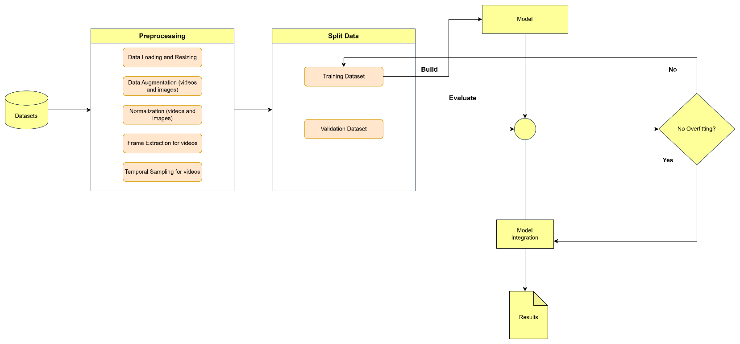
Figure 1 shows the overall proposed methodology for this project. This methodology was performed in two stages

Figure 1 the proposed methodology

5.1 OCR
This project implements an Optical Character Recognition (OCR) system using a Convolutional Recurrent Neural Network (CRNN) architecture designed to recognize text in images. The system utilizes synthetic data generated via the Text Recognition Data Generator (TRDG) library for pre-training, simulating diverse real-world text patterns. This approach enhances the model's robustness against various text styles and distortions.

5.1.1 Data Preparation
- Synthetic Data Generation: The synthetic dataset created by the TRDG library includes a wide variety of font styles, which helps to improve the model's adaptability.
- Preprocessing Pipeline: Input images are standardized to a fixed size of 128x32 pixels, incorporating padding and scaling to maintain aspect ratios. This normalization is crucial for consistent feature extraction.
- Label Encoding: Character labels are indexed using a unique character list derived from the dataset, allowing for efficient mapping of textual data into a numeric format suitable for training.

Figure 2 displays examples of text images in various fonts and styles, showing the diversity of the synthetic dataset. Each word is rendered in a different font, emphasizing the variety that aids the model’s training.

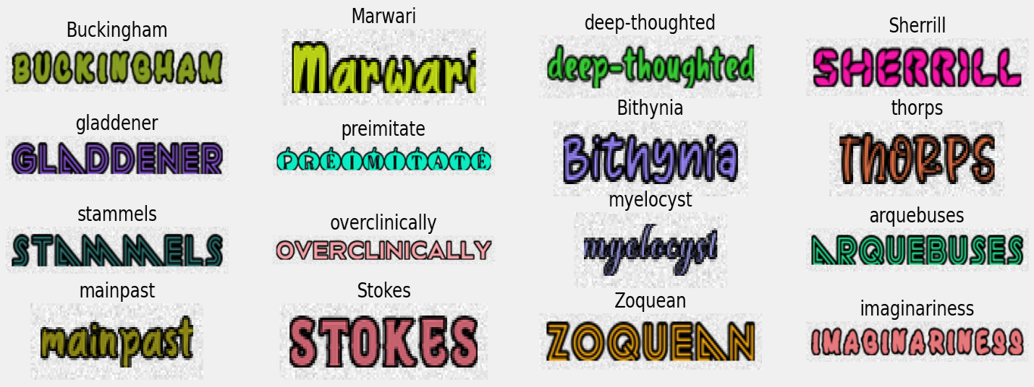

Figure 2

5.1.2 Model Architecture
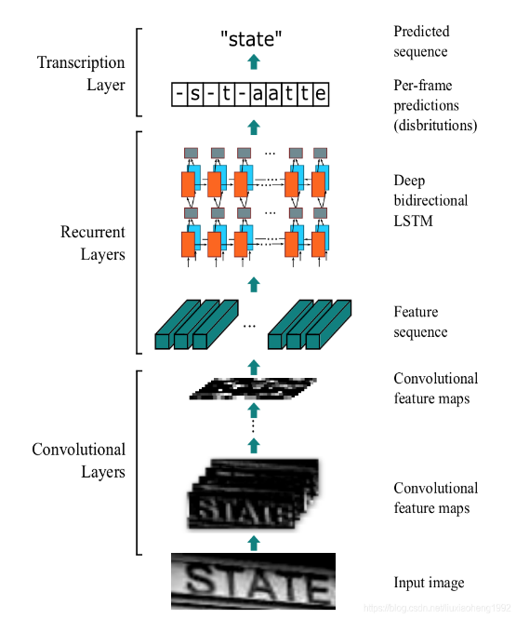
Figure 3 Model Architecture (https://blog.csdn.net/)

The CRNN architecture is selected for its effectiveness in text recognition tasks, combining convolutional layers for feature extraction with recurrent layers for sequence modeling.
- Feature Extraction (Convolutional Layers): Convolutional layers progressively extract spatial features from input images, while pooling layers reduce dimensionality and mitigate overfitting. Batch normalization stabilizes learning by normalizing intermediate feature maps.
- Sequence Modeling (Recurrent Layers): Bidirectional LSTM layers process sequential features extracted from the convolutional layers, capturing contextual information crucial for accurate character sequence interpretation.
- CTC Loss Function: The Connectionist Temporal Classification (CTC) loss function aligns predicted sequences with ground truth without explicit segmentation of text regions, essential for recognizing variable-length text strings.
5.1.3 Training Methodology
- Training and Validation Splits: The synthetic images and labels are divided into training and validation sets with a 90:10 ratio, minimizing CTC loss during training.
- Model Checkpointing: A checkpoint callback saves the model exhibiting the best validation performance, preventing overfitting.
- Evaluation Metrics: Metrics include Character Error Rate (CER) and Word Error Rate (WER), providing insights into model performance.
Initial training results indicate that the OCR model effectively learned from the synthetic dataset, achieving a CTC loss of 0.31570, a CER of 1.25%, and a WER of 9.32%. However, after fine-tuning on a real dataset of 5,000 words, performance declined, highlighting challenges in adapting the model to real-world contexts. Key issues include the domain gap between synthetic and real data, the limited size of the real dataset, and the potential need for more extensive retraining.
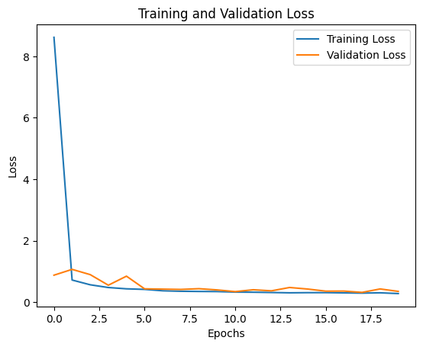
Figure 4

The graph shows training and validation loss decreasing significantly in the first few epochs and then stabilizing, indicating good model convergence. Training and validation loss are close, suggesting minimal overfitting. Slight validation loss fluctuations are normal but could benefit from further fine-tuning.
To address these challenges, I transitioned to full training with the real dataset, achieving a training loss of 6.0, with CER and WER results improving to 29.3% and 62.8%, respectively. Data augmentation techniques were introduced to enhance training diversity, simulating real-world variations and contributing to improved model performance.
5.1.4 Changes in Model Layers
Adjustments to the OCR model include adding an attention layer and a dropout layer, and switching the optimizer from Adam to RAdam. The attention mechanism improves the model's capacity to focus on crucial segments of the input sequence, while dropout regularization combats overfitting. The transition to RAdam enhances training stability, particularly with real-world data.
5.1.5 Model Results After Modifications
The modified model achieved promising results, with a CER of 19.37% and WER of 44.00%. These outcomes indicate that the adjustments positively impacted performance, although further refinements are necessary. Future work will involve incorporating Large Language Models (LLMs) for post-processing, aiming to enhance word-level prediction accuracy and overall model performance.
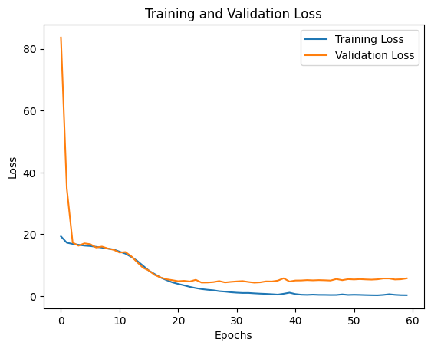
Figure 5

The graph shows a steep decline in both training and validation loss initially, followed by stabilization after ~10 epochs. Validation loss is higher than training loss, suggesting some overfitting, but the overall trend indicates decent convergence.

5.2 Object Detection
5.2.1 Data Collection
The project utilizes several datasets for object detection:
- Tiny ImageNet Dataset: Contains 200 classes, with 500 training images and 50 validation images per class, resized to 64×64 pixels for uniformity.
- CIFAR-10 Dataset: Comprises 60,000 32×32 color images across 10 classes, split into 50,000 training images and 10,000 test images.
- COCO2017 Dataset: A large-scale dataset designed for object detection, segmentation, and captioning tasks, including over 118,000 training images with diverse object annotations.
5.2.2 Preprocessing
- Cleaning and Resizing: Datasets are preprocessed to remove noise and standardize image dimensions.
- Normalization: Pixel values are normalized for consistent input distributions.
- Data Augmentation: Techniques such as random cropping, horizontal flipping, and rotation enhance model generalization and prevent overfitting.
5.2.3 Techniques
- Transfer Learning: Pre-trained ResNet models are initialized with ImageNet weights, with final layers adjusted to match the number of classes in each dataset.
- Fine-Tuning: Specific layers are fine-tuned while freezing others to balance computational efficiency and performance.
- Optimization: Learning rate scheduling, weight decay, and dropout are employed to optimize training.
5.3 Performance Metrics
Evaluation metrics include accuracy, precision, recall, F1-score, and loss metrics to assess model performance across datasets.

5.4 Sample of Results and Discussion
The fine-tuned ResNet models demonstrated varying performance levels:
- Tiny ImageNet: Performance was significantly impacted by overfitting. Despite data augmentation, the models struggled to generalize effectively.
- CIFAR-10: ResNet models achieved strong results, with ResNet50 performing best due to the dataset's balanced classes and sufficient size.
- COCO2017: Performance suffered from mild overfitting, indicating a need for further optimization and augmentation.

6. Results and Discussion
6.1 OCR Results and Discussion
The Optical Character Recognition (OCR) model demonstrated notable performance after implementing a Convolutional Recurrent Neural Network (CRNN) architecture, particularly when trained on synthetic data generated using the Text Recognition Data Generator (TRDG) library.
6.1.1 Performance Metrics
- CTC Loss: The model achieved an initial CTC loss of 0.31570 during training on synthetic data, indicating effective learning and feature extraction.
- Character Error Rate (CER): A CER of 1.25% was recorded, showcasing high accuracy at the character level.
- Word Error Rate (WER): The model achieved a WER of 9.32%, reflecting strong performance in recognizing word sequences.
These initial results highlight the model's capability to learn from diverse synthetic datasets, effectively recognizing characters and words. However, when transitioning to a real dataset containing 5,000 words, the model's performance declined significantly. The observed CER and WER increased, indicating challenges in generalization to real-world text.

6.1.2 Analysis of Performance Decline
Key factors contributing to this decline include:
- Domain Gap: The synthetic dataset lacks the noise, distortions, and variability present in real-world images, making it difficult for the model to adapt.
- Limited Real Dataset Size: The small size of the real dataset likely did not provide sufficient diversity for the model to learn effectively.
- Fine-Tuning Constraints: The decision to limit fine-tuning to the model's final layers may not have allowed adequate adaptation to the complexities of real-world text.
6.1.3 Improvements and Adjustments
To address these issues, a transition from fine-tuning to full training with the real dataset was implemented. The training loss improved to 6.0, with subsequent CER and WER metrics of 19.37% and 44.00%, respectively. This adjustment demonstrated that retraining the entire model allowed for better adaptation to the complexities of real-world text.
Additionally, the introduction of data augmentation techniques, including random rotations, cropping, and brightness adjustments, enhanced the diversity of training examples. This approach helped the model become more robust against real-world challenges, contributing to improved generalization during testing.
6.2 Object Detection Results and Discussion
The object detection component of the project utilized fine-tuned ResNet models across three datasets: Tiny ImageNet, CIFAR-10, and COCO2017. Each dataset presented unique challenges and opportunities for model evaluation.
6.2.1 Performance Metrics
- Tiny ImageNet: The ResNet models struggled with significant overfitting, resulting in limited generalization capabilities. Despite employing data augmentation and regularization techniques, the models did not achieve satisfactory performance on the validation set.
- CIFAR-10: This dataset yielded the best results, with ResNet50 achieving the highest accuracy. The balanced class distribution and sufficient data size contributed to strong model performance, demonstrating the effectiveness of the ResNet architecture for image classification tasks.

- COCO2017: The performance on COCO2017 was impacted by mild overfitting. While ResNet50 excelled in object detection tasks, achieving reasonable precision and recall, further optimization and augmentation are necessary to enhance generalization capabilities.
Figures 6, 7, 8 showcase sample of experimental results that we got.

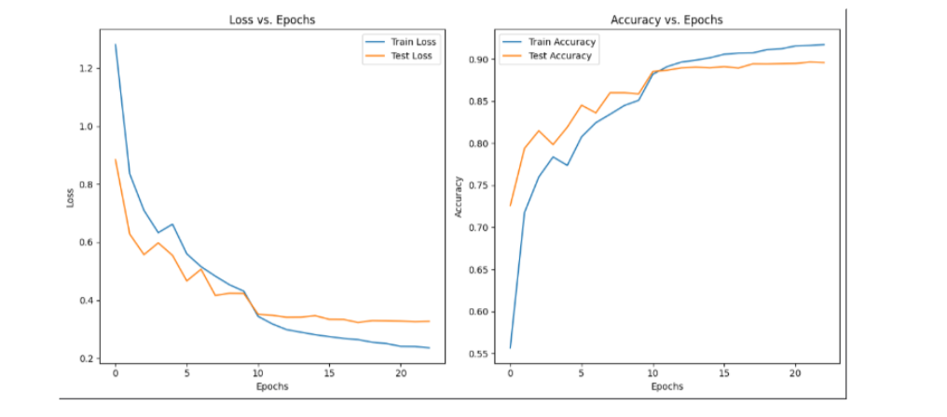

Figure 6 Results of ResNet50 on CIFAR-10

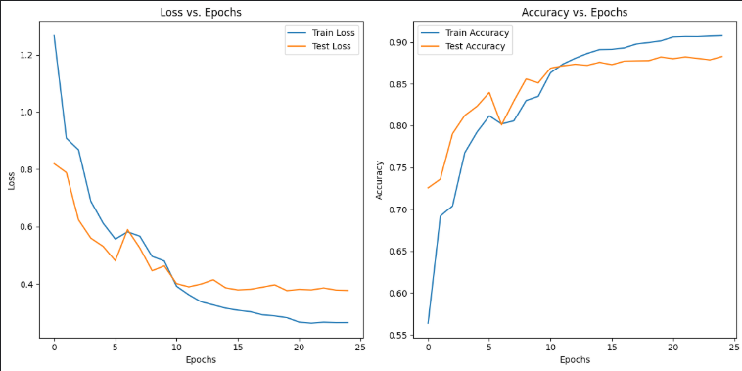

Figure 7 Results of ResNet50 on CIFAR-10

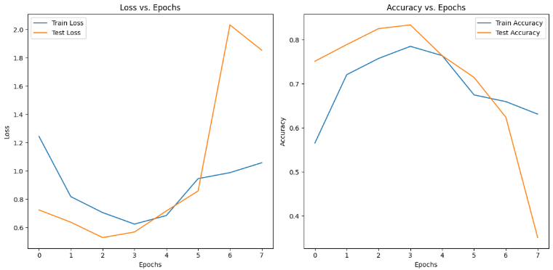
Figure 8 Results of ResNet152 on CIFAR-10

6.2.2 Analysis of Performance Variability
The variability in performance across different datasets highlights several important factors:
- Dataset Size and Variability: The limited size of the Tiny ImageNet dataset hindered the models' ability to generalize, while CIFAR-10's larger, more balanced dataset facilitated better learning outcomes.
- Complexity of COCO2017: The diverse annotations and complexities within the COCO2017 dataset require more advanced optimization techniques to fully harness the ResNet models’ capabilities.

.
7. Limitations
The project encountered several limitations that influenced the overall performance and applicability of the developed models:
- Data Limitations: The synthetic dataset utilized for training the OCR model lacked the inherent noise and variability found in real-world images. This absence of realistic conditions negatively impacted the model's ability to generalize effectively, leading to performance declines when applied to actual datasets. The synthetic data, while diverse in text styles, did not adequately represent the complexities of real-world scenarios, such as varying lighting conditions, text distortions, and background interference.
- Computational Constraints: Training deeper ResNet models for object detection necessitated significant computational resources, which constrained the ability to experiment with more complex architectures. The limited hardware capacity restricted the number of models that could be trained simultaneously, as well as the extent to which hyperparameters could be fine-tuned. This limitation may have prevented the exploration of potentially superior models that could offer enhanced performance.
- Overfitting: The issue of overfitting was particularly pronounced in datasets with limited samples, such as Tiny ImageNet. Despite employing various data augmentation techniques to enhance model generalization, the models struggled to perform well on unseen data. This highlights the need for larger, more diverse datasets to ensure robust learning and improved model performance.
8. Conclusion
This project successfully developed an integrated application combining Optical Character Recognition (OCR) and object detection, aimed at assisting visually impaired individuals. The implementation of a Convolutional Recurrent Neural Network (CRNN) for OCR and ResNet architectures for object detection demonstrated strong potential, yielding promising initial results. The OCR model effectively recognized characters and words from synthetic data, while the object detection models showcased their capabilities across various datasets. However, the transition to real-world data revealed critical challenges, particularly the synthetic-to-real domain gap, which needs to be addressed to enhance model robustness and applicability in practical scenarios.
The findings underscore the importance of continuous improvement and adaptation of the models to ensure they meet the needs of visually impaired users effectively. Addressing the limitations identified in this project will be crucial for the future success of this application.

9. Future Work
To build on the successes and address the limitations encountered, several future directions are proposed:
- Enhancing Synthetic Data: Future efforts will focus on improving the quality of synthetic datasets by incorporating noise and variability to better mimic real-world conditions. This enhancement aims to create more realistic training environments for the OCR model, thereby improving its generalization capabilities when applied to actual data.
- Exploring Advanced Architectures: There is a need to experiment with more advanced architectures, such as EfficientNet and Vision Transformers. These models may offer improved performance and efficiency compared to traditional ResNet architectures. Evaluating these newer models will help determine their suitability for both OCR and object detection tasks.
- Utilizing Large Language Models (LLMs): Implementing LLMs for post-processing of OCR outputs is another avenue for future work. By leveraging the contextual understanding of LLMs, the project aims to refine OCR outputs and improve Word Error Rate (WER) metrics. This integration could enhance the overall accuracy and reliability of the OCR system, making it more effective for users in real-world applications.
These future directions will be essential for advancing the project's goals, ultimately leading to more effective tools that support visually impaired individuals in their daily lives.

References
- Text Recognition Data Generator (TRDG). (n.d.). Retrieved from https://github.com/Belval/TextRecognitionDataGenerator
- Ba, J., & Caruana, R. (2016). Do Weight Averages Improve Neural Network Generalization? In Proceedings of the 33rd International Conference on Machine Learning (ICML) (Vol. 48, pp. 193-202). PMLR.
- Graves, A., & Jaitly, N. (2014). Towards End-to-End Speech Recognition with Recurrent Neural Networks. In Proceedings of the 31st International Conference on Machine Learning (ICML) (Vol. 32, pp. 1764-1772). PMLR.
- Zhang, Y., et al. (2019). An Attention Mechanism for Optical Character Recognition. IEEE Transactions on Image Processing, 28(11), 5289-5301. doi:10.1109/TIP.2019.2919928
- He, K., Zhang, X., Ren, S., & Sun, J. (2016). Deep Residual Learning for Image Recognition. In Proceedings of the IEEE Conference on Computer Vision and Pattern Recognition (CVPR) (pp. 770-778). IEEE.
- Redmon, J., Divvala, S., Girshick, R., & Farhadi, A. (2016). You Only Look Once: Unified Real-Time Object Detection. In Proceedings of the IEEE Conference on Computer Vision and Pattern Recognition (CVPR) (pp. 779-788). IEEE.
- Lin, T.-Y., et al. (2014). Microsoft COCO: Common Objects in Context. In European Conference on Computer Vision (ECCV) (pp. 740-755). Springer.
- Howard, A. G., et al. (2017). MobileNets: Efficient Convolutional Neural Networks for Mobile Vision Applications. arXiv preprint arXiv:1704.04861.
- Dosovitskiy, A., & Brox, T. (2016). Inverting VGG19: Backpropagating through the Decoder. In Proceedings of the IEEE Conference on Computer Vision and Pattern Recognition (CVPR) (pp. 4089-4098). IEEE.
- Kaiming He, et al. (2015). Delving Deep into Rectifiers: Surpassing Human-Level Performance on ImageNet Classification. In Proceedings of the IEEE International Conference on Computer Vision (ICCV) (pp. 1026-1034). IEEE.
- RAdam: A Method for Improving Generalization of Adaptive Learning Rate Methods. (2019). Retrieved from https://arxiv.org/abs/1908.03265
- Albumentations: Fast and Flexible Image Augmentations. (n.d.). Retrieved from https://albumentations.ai/

Updated on 5th of January 2025

